SD Card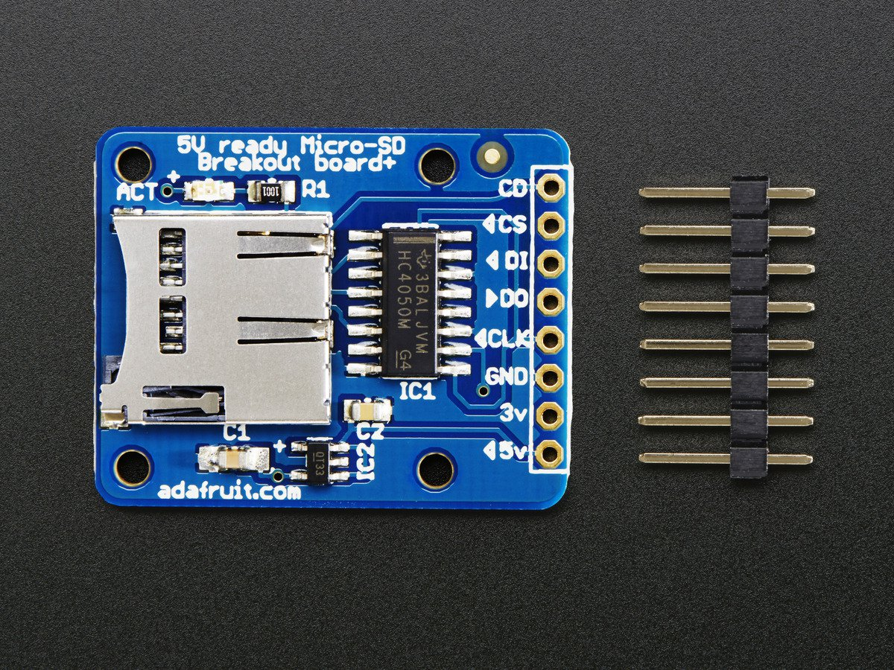

* CD: Card Detect
* CS: Chip Select
* DI: Data in
* D0: Data out
* CLK: Serial clock
* GND: Ground
* 3v: 3v power
* 5v: 5v power
* Using Adafruit SD breakout <https://learn.adafruit.com/adafruit-micro-sd-breakout-board-card-tutorial/look-out>
* Using SPI protocol instead of the faster SDIO because SDIO requires signing non-disclosure documents
* SPI uses a continuous stream of bits instead of packets like UART or I2C
  + Sync happens with a leader-follower relationship (formerly known as master-slave) and a clock
* Marauder:
  + Pins found in configs.h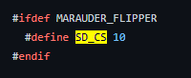
  + CD is SD_DET in source code, not sure if we need this?